

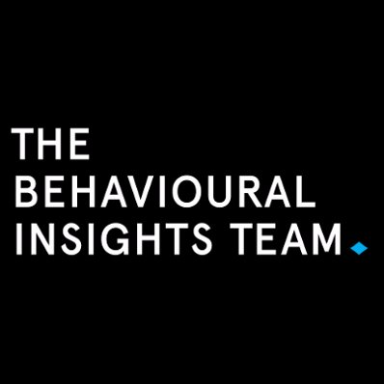

Applying Behavioural Economics to Increase the Take-up of Wage Subsidies

ISBN  
978-1-76051-393-1 [PDF]  
978-1-76051-394-8 [DOCX]



With the exception of the Commonwealth Coat of Arms, the Department’s logo, any material protected by a trade mark and where otherwise noted all material presented in this document is provided under a [Creative Commons Attribution 3.0 Australia](http://creativecommons.org/licenses/by/3.0/au/) (http://creativecommons.org/licenses/by/3.0/au/) licence.

The details of the relevant licence conditions are available on the Creative Commons website (accessible using the links provided) as is the full legal code for the [CC BY 3.0 AU licence](http://creativecommons.org/licenses/by/3.0/au/legalcode) (http://creativecommons.org/licenses/by/3.0/au/legalcode).

The document must be attributed as the Applying Behavioural Economics to Increase the Take-up of Wage Subsidies.

# Contents

Executive Summary 1

1. Background: Wage subsidies 3

2. Target: Define the scope of the trial 4

3. Explore: Pre-trial research activities 5

3.1 Barriers to take-up: administrative complexities 5

3.2 Barriers to take-up: financial incentives 10

3.3 Barriers to take-up: social incentives 13

3.4 Behavioural biases and lessons from behavioural economics on incentives 16

4. Solution: Cost-effective ways to improve the program 21

4.1 The new wage subsidy agreement 23

4.2 Promotional flyer 23

4.3 The new default payment structure 24

4.4 Scripts and email 26

5. Trial 27

5.1 Design 27

5.2 Evaluation questions 28

5.3 Randomisation 29

5.4 Analysis 29

5.5 Results 30

6. Conclusion 33

Appendices 34

Appendix A – Summary of BIT TEST Framework 34

Appendix B – Expression of Interest to recruit trial partner 35

Appendix C – Partner Selection Criteria 37

Appendix D – Deed of Understanding 38

Appendix E – Explore material 39

Appendix F – Trial Protocol 45

Appendix G – Regression tables 46

Appendix H – References 48

# Figures

Survey result – admin complexity 6

Survey result – wage subsidy discussion frequency 6

Focus group insights on administration, March 2016 7

Wage subsidy administration process map as at March 2016 9

Survey result – wage subsidy attractiveness 10

Survey result – wage subsidy attractiveness by sector 10

Department data analysis – wage subsidy agreements by size of provider site 11

Survey result – wage subsidy attractiveness by employer type 11

Focus group insights on financial incentives 12

Survey result – the effect of wage subsidies on employment outcomes 13

Department data analysis – type of job seeker helped by wage subsidy 13

Wage subsidy type by stream 14

Focus group insights on social incentives 15

Results of the Save More Tomorrow program 17

Survey result – negative perception of wage subsidies 19

The online wage subsidy agreement 23

One of the new wage subsidy promotional flyer 24

A screenshot of the new, easy to use wage subsidy calculator 25

A selection of materials in the wage subsidies training manual 26

Team allocation to the treatment group 29

Trial result – average number of agreements signed per day 30

Trial result – proportion of job seekers reaching the 4 week outcome 30

Trial result – average number of days taken to finalise agreement 31

Trial result – average number of wage subsidy activities done by job advisors per day 31

Trial result – average number of agreed hours per wage subsidy agreement 32

# Tables

Wage subsidies provided by the Department in 2016 (all figures GST inclusive) 3

Summary of research activities 5

Our Explore findings and corresponding interventions 21

The revised wage subsidy payment structure 24

Our primary intervention evaluation questions 28

Our secondary intervention evaluation questions 28

Summary of results 32

The TEST framework 34

# Behavioural Economics Applications to Increase the Take-Up of Wage Subsidies

# Executive Summary

Wage subsidies are payments to encourage businesses to employ eligible job seekers.

In 2016, the Behavioural Insights Team (BIT), the Applied and Behavioural Economics Section and the Incentives and Investments Branch of the Australian Government Department of Jobs and Small Business (formerly the Department of Employment, furthermore referred to as the Department), in partnership with jobactive employment services provider Mission Providence, co-designed and implemented a behavioural economics trial with the aim of increasing the take-up of Australian Government wage subsidies.

The early research phases of the project identified three main areas for improvement in the way wage subsidies were delivered: (i) administrative complexities for both jobactive providers and employers; (ii) financial incentives for employers not being framed correctly; and (iii) social incentives not being taken into consideration as a complement to the payments.

The new behavioural economics trial did not change the amount of the subsidies or the policy, but rather looked at testing small changes, including:

* improving administrative processes, by making wage subsidy agreements easier for employers to understand and allowing them to sign online with an electronic signature;
* restructuring of payment instalments to increase attractiveness and enhance loss aversion of employers; and
* improving communication and marketing materials for jobactive staff to promote wage subsidies to job seekers and employers.

The new approach was tested across five of Mission Providence’s sites in South West Sydney, on a sample of 1,436 employers, between 25 July 2016 and 1 November 2016. The effectiveness of the new approach was evaluated using a cluster Randomised Control Trial, with a stepped-wedge design.

We found that our trial caused an increase in the number of wage subsidy agreements signed. Specifically, an additional two agreements were signed per month at each site. While the higher level of agreements signed is associated with higher average hours worked per placement (an average of two hours per week per wage subsidy), there was also a small reduction in the likelihood of being employed for four weeks, 12 weeks and 26 weeks. However, apart from the average hours worked per placement, these differences were not significant at conventional levels. The intervention also resulted in a reduction in the time taken to finalise an agreement (from an average of 17 to 11 days), although this did not reach conventional levels of statistical significance. We also found a large and statistically significant increase in promotional activity by 60 per cent.

These results suggest that the intervention was effective in increasing the number of wage subsidy agreements signed online, but due to a lower than expected sample size, our trial ultimately did not allow us to be more definitive about the efficacy of the changes made.

The insights and results from this trial show how financial incentives per se might often not be sufficient if not informed by how individuals really behave. Based on an improved understanding of employers’ preferences and jobactive provider staff behaviour, this trial shows that small changes to the existing policy can have a significant effect.

Feedback received during the trial fine-tuned the final design and implementation of operational policy changes to wage subsidies announced in the 2016 Budget and implemented nationally on 1 January 2017. These include:

* Giving employers longer to sign up to an agreement: wage subsidy agreements can be signed up to 12 weeks after the job starting, extended from four weeks.
* Making the application and payment processes easier: improving online functionality for employers and providers to simplify eligibility, agreements and claim processes.
* Providing more timely financial support: a discretionary kickstart payment option of up to 40 per cent can be made four weeks after the job seeker starts in the job.
* All wage subsidies paid to employers over six months instead of the previous 12 months.
* Increasing flexibility for employers and job seekers: moving to an average of 20 hours worked per week over the six month agreement rather than a minimum requirement of 15 hours per week worked.

# 1. Background: Wage subsidies

Australian Government wage subsidies provide financial incentives to employers who hire eligible job seekers by providing a payment of up to $10,000 (GST inclusive). The assistance is generally intended to offset the initial costs that are incurred in recruiting and training new staff, however, they are not tied to any particular cost or purchase. Eligibility of job seekers is based on a set of socio-demographic characteristics and unemployment history, as summarised in Table 1 below:

Table 1. Wage subsidies provided by the Department in 2016 (all figures GST inclusive)

| **Name** | **Description** |
| --- | --- |
| Restart | Up to $10,000 to hire a job seeker 50 years of age and over |
| Youth wage subsidy | Up to $6,500 to hire a job seeker under 30 years of age |
| Parents wage subsidy | Up to $6,500 to hire a job seeker who is a parent |
| Long Term Unemployed and Indigenous wage subsidy | Up to $6,500 to hire a long-term unemployed job seeker (12 months) or an Indigenous job seeker (with 6 months of unemployment) |

Despite the financial benefits of wage subsidies, the take-up by employers remains modest.

The following sections of this report are structured around BIT’s TEST framework (see Appendix A for a summary). All appendices and additional materials are provided at the end of the document or separately.

# 2. Target: Define the scope of the trial

To define the specific behaviours we aimed to change, and identify clear and measurable outcomes, we conducted a Target phase consisting of the following activities.

| **Date** | **Behaviour** |
| --- | --- |
| Oct 2015 | We facilitated a three-day workshop at the Australian and New Zealand School of Government (ANZSOG) in collaboration with the Incentives and Investments Branch of the Department.  During the workshop, participants visited or called providers to gain a better understanding of the reasons for low take-up. Their insights suggested this is not due to a specific factor, but a number of behavioural and system bottlenecks from both employers and providers. Data analysis by the Department also suggested the issue is not confined to a set of employers or job seekers, but is present across most regions and sectors. |
| Jan 2016 | The Department and BIT undertook group interviews and surveys with approximately 150 staff members from multiple providers in eight different locations in Australia to identify barriers to the promotion and management of wage subsidies.  The Department sent out an Expression of Interest (EOI) (see Appendix C) to all jobactive providers to be nominated as a field partner to trial a new way to promote and manage wage subsidies. Twelve jobactive providers responded and were reviewed and jointly assessed by BIT and the Department based on a number of criteria (see Appendix B). |
| Feb 2016 | Based on follow up conversations with short-listed providers, Mission Providence was selected as the project partner (for the Deed of Understanding signed by all parties see Appendix D). |
| Apr 2016 | BIT and the Department worked closely with Mission Providence Senior Management and frontline staff to further refine the scope of the trial and adapt potential solutions to the existing service delivery system. Solutions that could then be scaled-up and adopted by all providers around the country were prioritised. |

# 3. Explore: Pre-trial research activities

Designing a new wage subsidy delivery model required a better understanding of the reasons behind the low take-up of wage subsidies and the common issues faced by providers in managing it. To gather this information, BIT and the Department undertook a series of in-person consultations with providers and employers.

We used a combination of qualitative and quantitative research methods to collect this information in a way that was as unbiased and reliable as possible. The methods used are summarised in the table below, and a copy of the research materials used is provided in Appendix E.

Table 2. Summary of research activities

| **Research Method** | **Description** |
| --- | --- |
| Staff Survey | We administered an anonymous survey to 126 staff members of different levels of seniority and experience across multiple providers across Australia. |
| Focus Groups | We conducted group interviews with approximately 150 staff members from multiple providers across eight different locations in Australia.[1] |
| Interviews | We interviewed staff from 13 employers from different locations and industry. |
| Workshop | We held a one-day workshop with Mission Providence staff to visually map the entire management process of a wage subsidy, from promotion to disbursement of the last payment to the employer. |
| Data Analysis | We analysed administrative data from the Department data system ESS. |

A cross-analysis of the insights gathered revealed that the main and most recurrent areas for improvement could be summarised in three main categories:

* Administrative complexities
* Financial incentives
* Social incentives

The following sections provide a detailed analysis of each of these categories and how they informed the development of feasible solutions. Some of the areas for improvement suggested a strong overlap with potential solutions offered by the behavioural economics literature. We offer a review of a selected number of relevant studies in the last part of this section.

## 3.1 Barriers to take-up: administrative complexities

Wage subsidies are an important tool for staff at jobactive providers. They can be used not only to increase the hiring and retention of job seekers (and to receive the related employment outcome payments from the Department), but to foster stronger relationships with employers.

These benefits, however, are not immediately apparent in the day to day tasks performed by staff. Due to the administration involved in the management and promotion of subsidies, staff often do not prioritise them.

### Insights from staff survey

The administrative complexities presented by wage subsidies were reflected in the staff survey. Responses revealed that:

* more than two thirds of staff did not find wage subsidies easy to manage and administer while only 2 per cent of staff did; and
* 60 per cent of staff said they would discuss wage subsidies with employers only sometimes or sporadically.

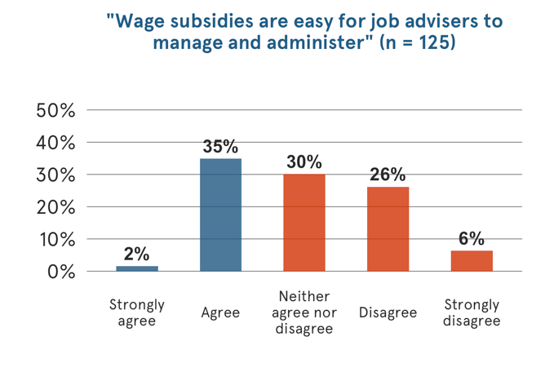

Figure 1. Survey result – admin complexity

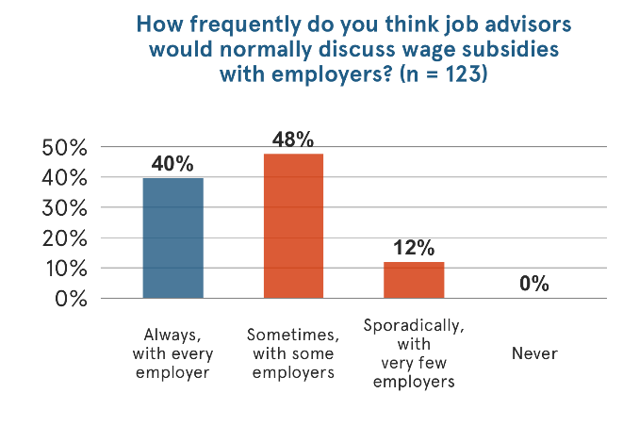

Figure 2. Survey result – wage subsidy discussion frequency

### Insights from focus groups and interviews

We collected more in-depth information about administrative barriers during focus groups and interviews with staff and employers. During these, staff often mentioned that:

* employers often did not sign the agreement within the required 28 days from when the job seeker starts in the new job;
* employers did not provide payslips or other evidence of employment in time; and
* providers found it difficult to align internal processes and systems with Department policies and reporting mechanisms.

Staff also acknowledged that recent simplifications to the agreement in the trial, such as providing a template and reducing the number of required signatures to just one, were welcomed improvements, but further changes in the same direction were still needed.

A selection of the insights gathered from the focus groups around administrative complexities are presented below.

Figure 3. Focus group insights on administration, March 20161

Central to the flowchart is administration. 5 main learnings branch from this from the focus group; internal processes of providers can be burdensome; the online agreement form is easy to use; administration is a burden on employers; administration of payments is burdensome for providers and; quarterly payments are used as a default option. Surrounding these branches are quotes from the focus group that support these learnings.

1 Note these focus groups were conducted in 2016, prior to the 1 January 2017 changes to wage subsidies.

2 The January 2017 changes included providing an option for earlier financial support: a discretionary kickstart payment of up to 40 per cent can be made after four weeks of the job placement.

3 The January 2017 changes included making the application and payment processes easier: improving online functionality for employers and providers to simplify the creation and management of agreements and claim processes.

4 The January 2017 changes included giving employers longer to sign up to an agreement: wage subsidy agreements can be signed up to 12 weeks (84 days) after the job starting, extended from four weeks.

### Map of the wage subsidy administration process

In April 2016, BIT and the Department also ran a one-day workshop with staff at Mission Providence in Ingleburn (NSW). The workshop consisted of mapping the administrative process from beginning to end.

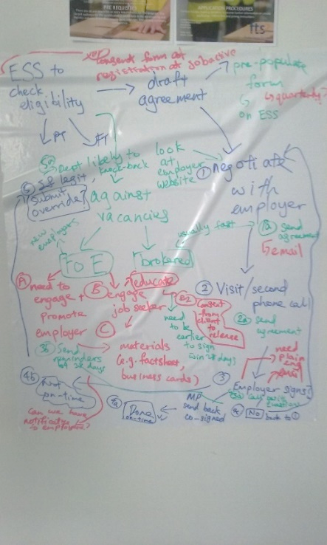

The output of these consultations is summarised in the process map below. Most of the behavioural and system bottlenecks highlighted by staff confirm those mentioned by staff from other providers during focus groups and surveys. For example:

* provider staff do not have a consistent process for promoting subsidies over the phone and email with employers and job seekers. This means providers often rely on the skills and experience of the individual staff member to promote subsidies effectively;
* provider staff do not have tailored marketing and promotional material that they can use to send further information via email to employers if asked;
* employers often call back to ask further information as the wage subsidy agreement is not clear or contains misleading framing about a job seeker’s quality due to the name of the wage subsidy. Mission Providence staff suggested that some employers would change their mind about the wage subsidy after receiving a copy of the agreement to sign, reporting titles such as  
  “Long Term Unemployed and Indigenous Wage Subsidy Agreement” send a signal of low quality in regards to the job seeker;
* employers often do not have access to a printer and scanner to sign and send back a signed copy of the agreement to the provider within the required 28 days; and
* provider staff find it difficult to chase employers during the whole duration of the subsidy agreement to ask them to provide evidence of continuing employment to disburse payments.

Figure 4. Wage subsidy administration process map as at March 20161

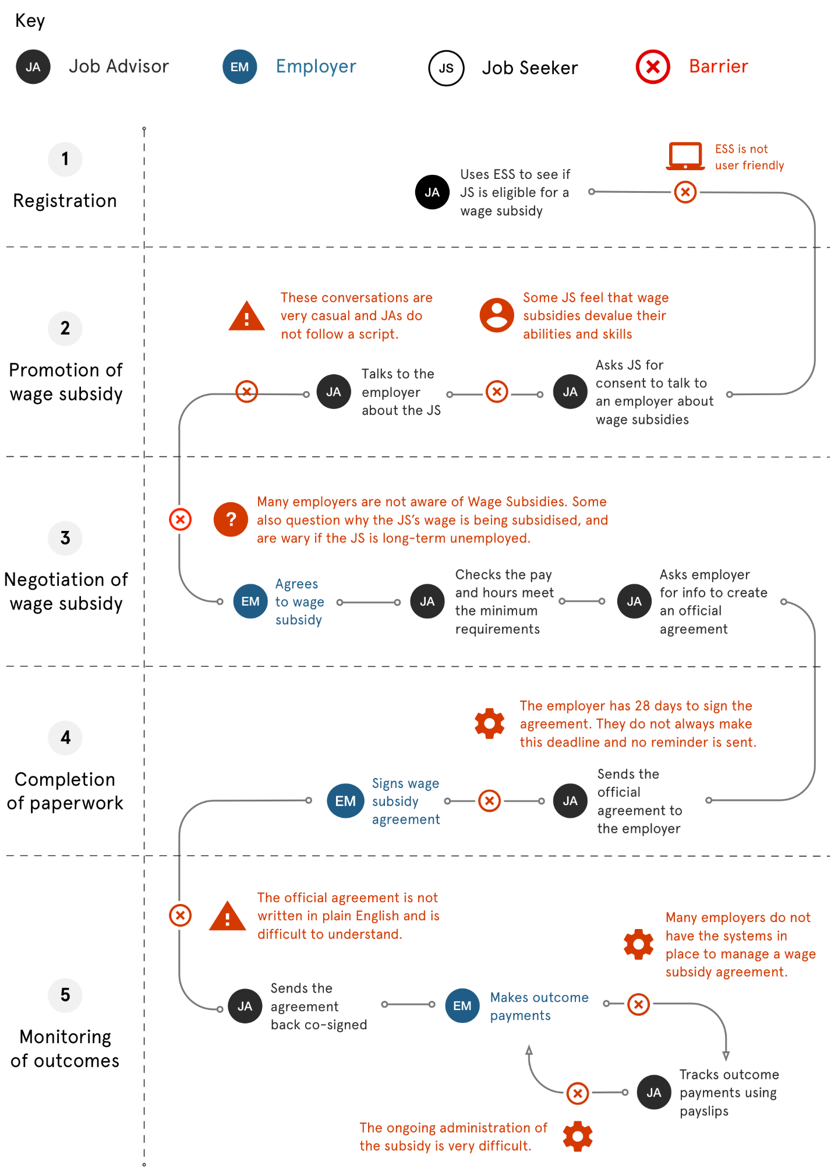

1 Note that this administration process map was developed in 2016, prior to the 1 January 2017 changes to  
wage subsidies.

## 3.2 Barriers to take-up: financial incentives

Wage subsidies can be accessed by most Australian employers in Australia, regardless of size or sector. Not all employers, however, are aware of them, and it is ultimately up to providers to promote them.

One of the purposes of the survey and focus groups was to explore the hypothesis that the relatively low awareness of subsidies among employers might be explained by behaviour and perceptions of provider staff around the effectiveness of subsidies. Specifically, we wanted to look at whether provider staff had any subjective bias in assessing which employers to approach and how frequently to promote subsidies.

### Insights from staff survey

Survey results show that about one third of staff did not think most employers would find wage subsidies attractive. And only 10 per cent strongly agreed that employers would be attracted by wage subsidies.

Whilst this response might be based on particular occasions when provider staff had their offer of subsidies rejected by employers, it does reveal a strong assumption behind staff behaviour on the attractiveness of subsidies. This assumption can be expected to influence the likelihood of staff promoting subsidies as well as their ability to convince employers about their benefits.

In addition, the survey also aimed to shed light on whether other assumptions from staff might be driving lower than expected take-up across industries or sectors. It is reasonable to not expect provider staff to know what the overall use of subsidies has been across industries and sectors in Australia, however, the survey questions allowed staff to select “all that apply”. Whilst these comparative analyses should be taken with caution (e.g. some staff might have interpreted the question as what type of employers in their specific area might be more attracted to wage subsidies), it is an indication of further assumptions that only some employers would be interested.

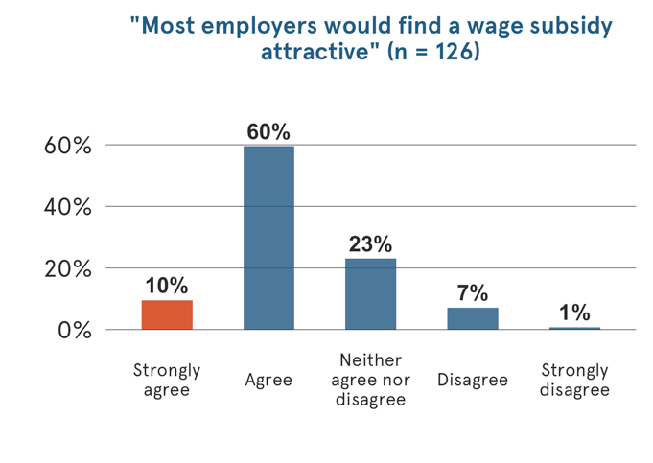

Figure 5. Survey result – wage subsidy attractiveness

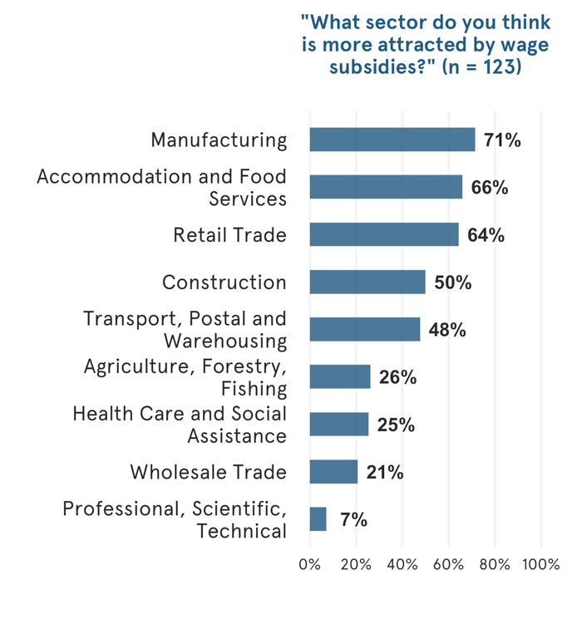

Figure 6. Survey result – wage subsidy attractiveness by sector

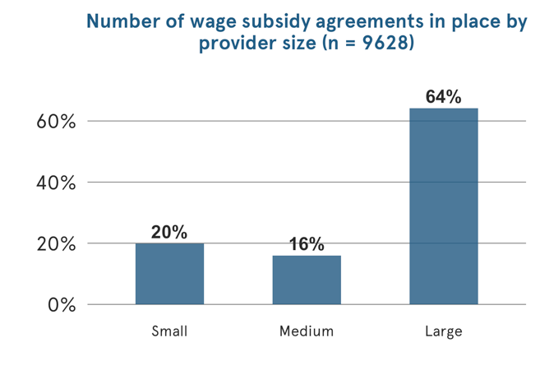 Figure 7. Department data analysis – wage subsidy agreements by size of provider site

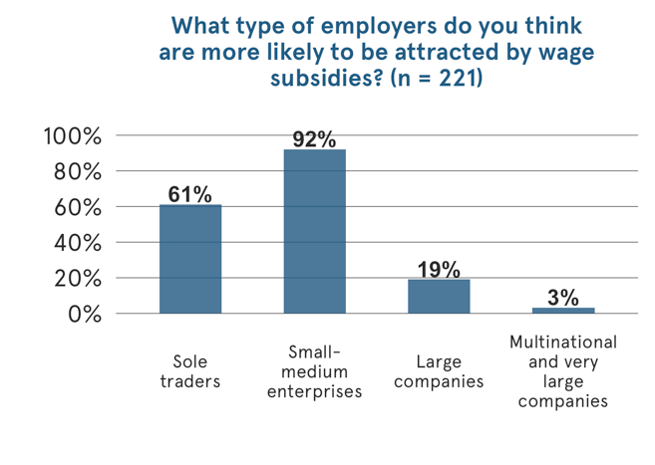 Figure 8. Survey result – wage subsidy attractiveness by employer type

### Insights from focus groups and interviews

Discussions with staff and employers revealed that there are often contrasting opinions across providers. Similarly, discussions between providers and employers revealed contrasting opinions about the attractiveness and effectiveness of subsidies.

In addition, low awareness and biased assumptions about employers’ interests were identified as potentially important determinants of the low take-up. The amount of the subsidy seemed to be about right for employers, although providers felt it could be higher.

A selection of the most frequently recurring issues gathered around financial incentives is presented below.

Figure 9. Focus group insights on financial incentives

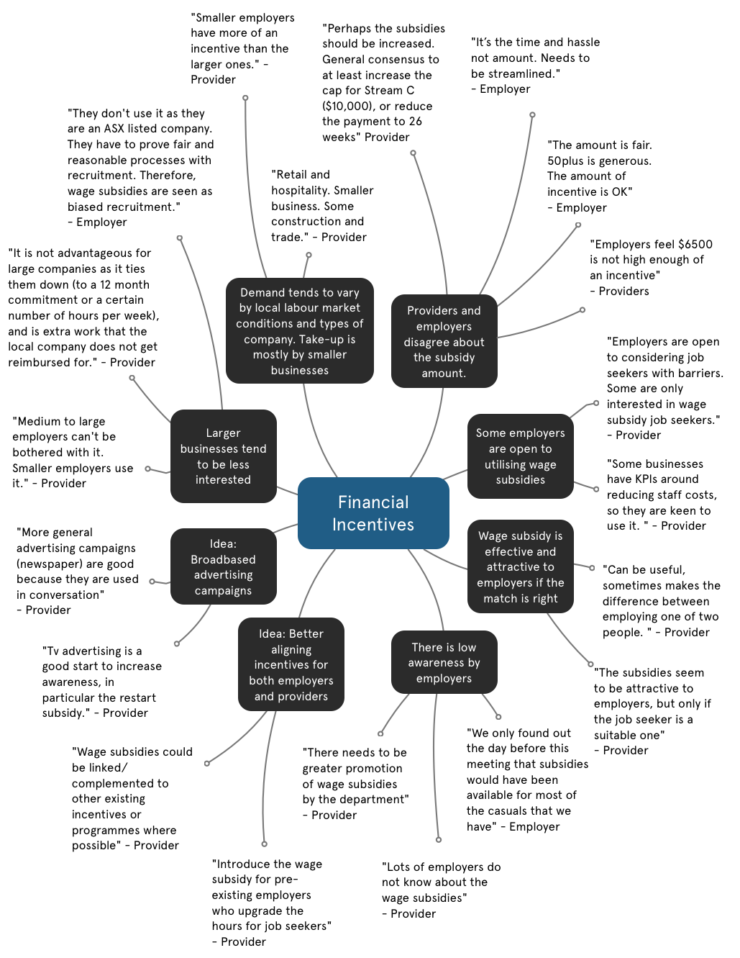

## 3.3 Barriers to take-up: social incentives

Provider staff have a strong incentive to place the most suitable job candidate in the most suitable vacancy. Wage subsidies can be a useful financial incentive to help achieve this outcome, but not all staff perceived it as such.

### Insights from staff survey

Survey responses show that while most staff thought subsidies could be an effective tool to improve employment outcomes, about 15 per cent did not agree.

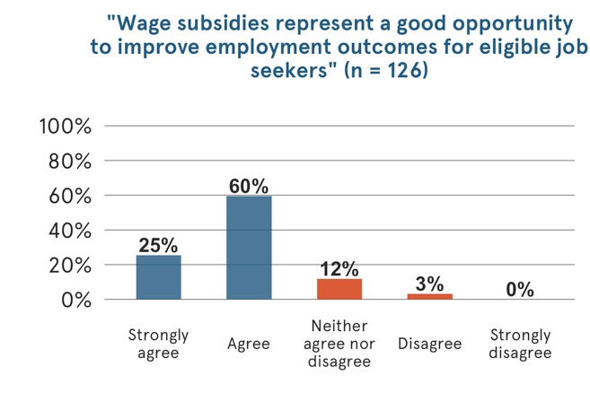

Figure 10. Survey result – the effect of wage subsidies on employment outcomes

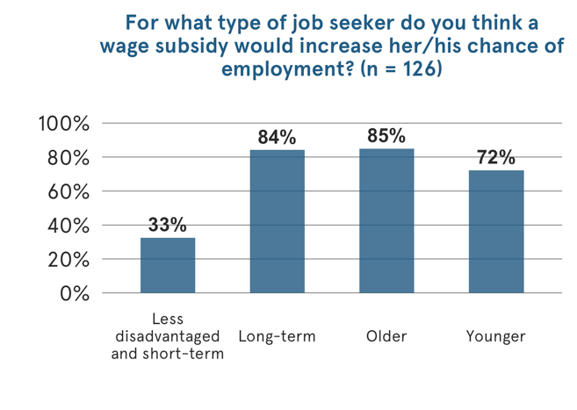

Figure 11. Department data analysis – type of job seeker helped by wage subsidy

Similar to the assumptions about employer interest in subsidies, staff also had preconceptions about which job seekers would benefit the most from the subsidies. The survey included the question “*For which type of job seeker do you think a wage subsidy would increase her/his chance of employment – please select all that apply*”.

The answers purposely allowed staff to select all types of eligible job seekers, but not all staff did this (approximately 20 per cent on average failed to identify eligible job seekers from the list). Job seekers eligible for the Long Term Unemployed and Indigenous wage subsidy were perceived as the least likely to benefit from a subsidy, according to staff. However, analysis on admin data from the Department reveals, in fact, that this subsidy had the highest numbers (see Figure 12 below).

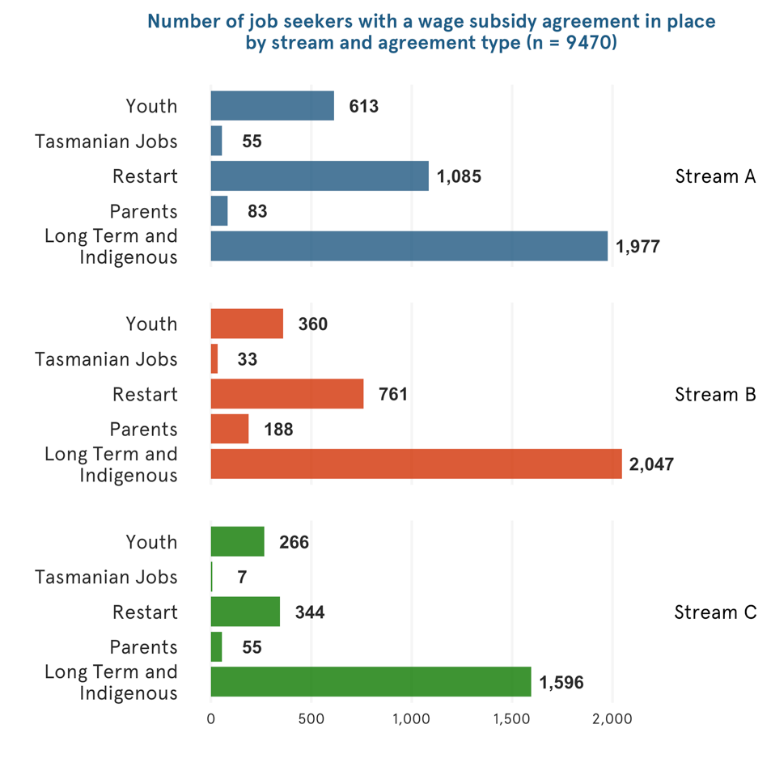

Figure 12. Wage subsidy type by stream

### Insights from focus groups and interviews

Mapping all common themes mentioned by staff when discussing the non-financial element of wage subsidies, a number of recurring issues were highlighted. These included the name ‘Wage Subsidy’ and the title of subsidy types (e.g. Long Term Unemployed and Indigenous) sending the wrong signals about the quality of a job seeker to the employer. Whilst some staff reported having some counteracting strategies, such as not mentioning the name of the subsidy to the employers, the wage subsidy agreement to be signed included such information.

Staff also reported some negative perceptions among job seekers, who sometimes preferred the provider not to mention the subsidy to potential employers for fear of negative perceptions. Staff also lamented that they do not have access to promotional material they could use to promote subsidies more effectively to both employers and job seekers.

A selection of the most frequently recurring comments gathered around social incentives are presented below.

Figure 13. Focus group insights on social incentives

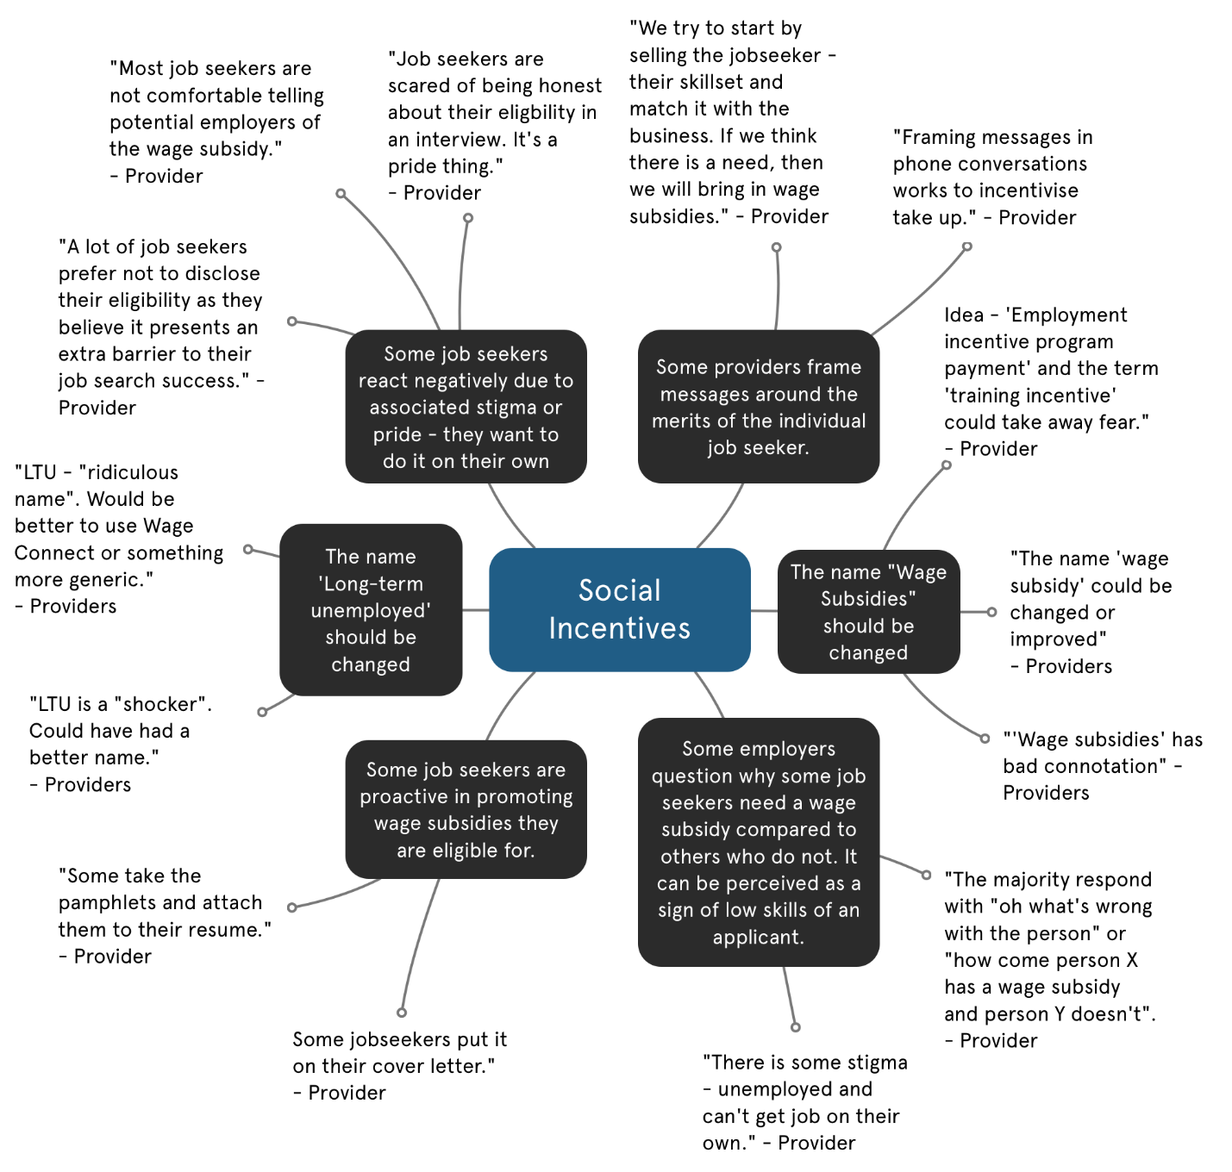

## 3.4 Behavioural biases and lessons from behavioural economics on incentives

Standard economic theory predicts that in most circumstances financial incentives should lead to a change in behaviour. More recent literature from behavioural economics instead shows that seemingly irrelevant factors, such as the way incentives are framed, can enhance or limit their effectiveness.

Our fieldwork led us to identify a number of behavioural biases that may be affecting the take-up of wage subsidies. Below we provide a summary of key insights from a selected set of studies that inspired the redesign of the program.

### Choice architecture and defaults

We often do not make the best choices for ourselves. A typical example of this is retirement savings. Although they are important, most people do not analyse the superannuation market to choose the best option for themselves. Rather, they often stay with the fund chosen automatically by their first employer.

One example of this behaviour comes from a trial by Thaler & Benartzi (2004), which aimed to increase retirement savings among employees of a group of companies in Chicago. The authors designed a programme called Save More Tomorrow that had four key components:

1. Employees were offered the advice of a financial consultant, and if they declined, they were asked to increase their retirement plan contribution rates starting at some point in the future, removing the feeling of giving up disposable income in the immediate term.
2. The plan increased the savings rate only after a nominal raise, so their pay check amount was not lower than it was in the past.
3. The savings rate continued to increase with each raise until it reached a pre-set maximum.
4. Most importantly, employees would remain enrolled in the programme by default, but could opt out at any time.

Most of these components do not fit the standard notion of an incentive—they do not offer a higher interest rate or a higher matching rate by the employer. Yet, when the programme was introduced, it was very effective: the average savings rate for the participants increased from 3.5 per cent to 13.6 per cent over the course of 40 months[2] (Kamenica, 2012). These findings are summarised in Figure 14.

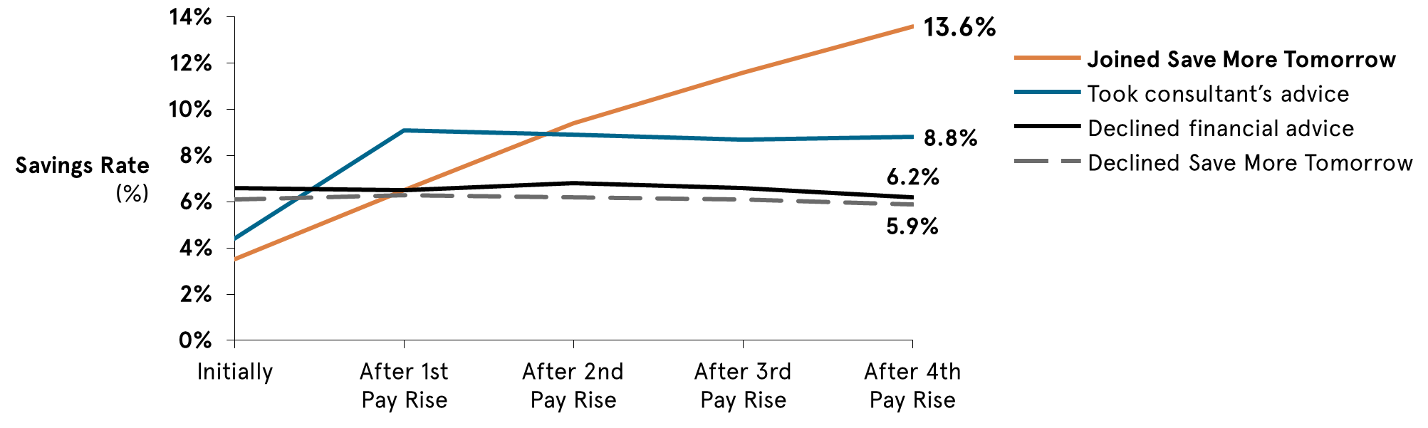

Figure 14. Results of the Save More Tomorrow program

Removing small friction costs of having to continually choose to increase savings levels proved an effective mechanism to help them make better decisions for their future.

This example is of particular relevance to wage subsidies. The current model allows for maximum flexibility for employers, who can choose how they want their subsidy payment instalments to be split, while still being pro-rata. This, however, means that for every signed agreement, provider staff have to re-calculate the amount and dates of instalments, taking into account variables such as duration of employment, number of working hours per week, and type of subsidy among others. Further, as employers must provide evidence of ongoing employment, provider staff often have to follow up multiple employers at different times to obtain payslips.

Conversations with staff at different providers suggest that, despite the clear flexibility clause in the policy, providers and employers often agree on the default option of splitting subsidy instalments on a quarterly basis over 12 months, even though there is no evidence that this is the most attractive option for employers.

Furthermore, it is possible that one of the reasons for the low take-up has been the implicit resistance of staff at jobactive providers to make numerous phone calls to promote subsidies, knowing the administrative complexities that lie ahead.

### Loss aversion

There is evidence that individuals are more motivated by losses than gains. For example, paying teachers 8 per cent of their salary upfront, which is lost if pupils do not achieve a certain score, increased student test scores by 10 per cent, while a normal bonus of 8 per cent did the same as no reward at all (Fryer et al., 2012).

Similar effects can be found if the incentives are just presented as the avoidance of potential losses (i.e. people do not actually receive the money in advance) although the effect is smaller. For example, if employees are provisionally paid a bonus, dependent on achieving a target in the following week, their productivity is 1 per cent higher than those who are told they will get a certain bonus if the target is met (Hossain and List, 2009).

The possibility of arranging subsidy payments in a flexible manner can allow providers to suggest a default option that includes higher instalments upfront, which can then be deducted from the employer should the new employee not reach weekly milestones. This can be expected to enhance loss aversion in employers, who would rather keep employees for longer, and if unsatisfied with their performance, try to help them improve their performance rather than cease their employment. This can also be expected to prevent possible high turnover rates of employees.

### Hyperbolic discounting

Individuals disproportionately prefer rewards that come sooner and costs that are borne later (Laibson 1997). This is an issue for the uptake of many services as many of the benefits can seem a long way off. Often we choose smaller benefits – not putting the time and effort into adopting a new approach – over larger, but more distant ones. This behavioural bias is known as hyperbolic discounting.

Time spent with provider staff revealed that daily tasks can be numerous and wage subsidies are not often a priority on their to-do list. Most providers would agree that wage subsidies represent an opportunity to increase placements and retention of their job seekers, but these rewards are more visible in the future, such as after 10-12 weeks of employment of a job seeker, and are not immediately apparent.

Similarly, employers who face higher upfront costs during the first weeks of hiring a new employee (e.g. training costs) might perceive a wage subsidy as a useful tool to cover these costs in the short-term, rather than several weeks or months after initial appointment.

One strategy to increase adoption is to shift the point in time when the benefits and costs occur. For example, increasing the salience of immediate rewards can have significant effects, such as notifying employers in a more attractive way that they are about to receive a relatively larger portion of their subsidies in the first days and weeks of employment.

### Signalling and framing effects

The impact of framing and signalling on financial incentives is a long studied topic in behavioural economics. In a study by Frey Felix Oberholzer-Gee (1997), residents of a Swiss town were asked whether they would support the construction of a nuclear power plant close to their town. One group was told that if they agreed for it to be built, they would receive a non-negligible sum of money in exchange. This group was found to be less supportive of the construction of the plant compared to a group who was offered no reward. The common explanation is the monetary incentive implies the plant must be dangerous, and no one else would have agreed to have it constructed in their town.

Discussions with provider staff revealed that how subsidies are framed can have important implications for the likelihood of an employer accepting. Staff across different providers mentioned that sometimes wage subsidies might send a negative signal about a job seeker’s qualities and skills, with several staff members reporting employers asking questions such as “*What’s wrong with this job seeker that he/she needs a wage subsidy?”.*

This signalling effect is also reinforced by the way subsidies are framed during contractual negotiations. After employers agree to take on the job seeker with the subsidy, they are asked to sign an agreement – i.e., the wage subsidy agreement. Whilst the agreement provides valuable information about the incentive, it also highlights the particular type of subsidy the job seeker is eligible for on top of the document, such as ‘*Long Term Unemployed and Indigenous Wage Subsidy*’. Several providers’ staff members suggested that this framing often puts employers off and might make a difference to their willingness to finalise the arrangement.

Further, the titles of subsidies refer to the technical terminology used by the Department, where, for instance, long-term unemployed refers to any job seeker who has been on income support for a minimum of six months, which might not necessarily be considered as a long time by an employer.

Based on negative reactions received by employers, about 40 per cent of the provider’s staff surveyed reported not mentioning wage subsidies to employers, for fear it would send the wrong message about the quality of a job seeker they are trying to help.

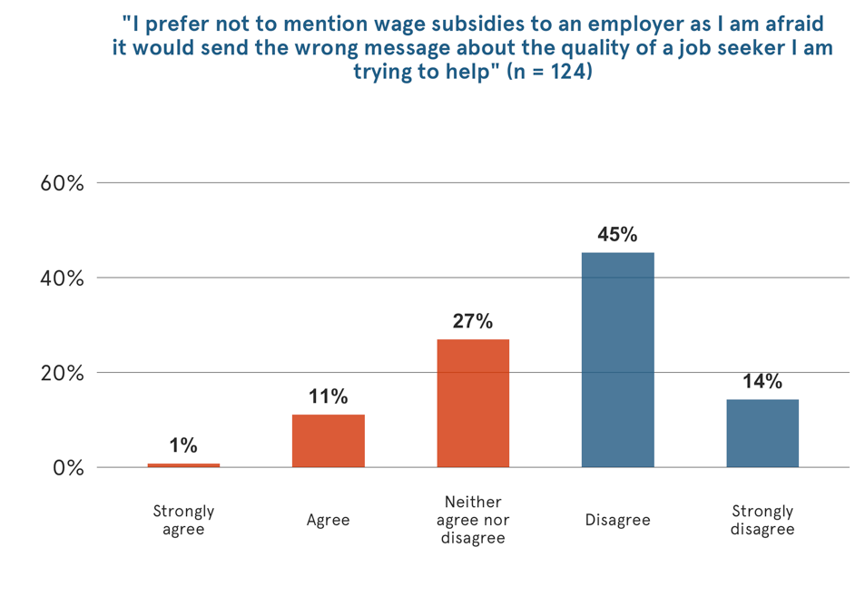

Figure 15. Survey result – negative perception of wage subsidies

### Anchoring effects

Anchoring describes the effect whereby the first piece of information we are presented with often heavily influences our future decision making. This is particularly the case with numerical information. For example, research from the US and the UK has found that increasing the minimum payment amount displayed on a credit card statement tends to see an increase in the average payment amount (Navarro-Martinez, Salisbury, Lemon, Matthews, & Harris, 2011). Displaying the amount that it would take to pay off the balance in a specified timeframe (e.g. 36 months), also leads to a spike in payments that match that amount. Similarly, when determining what percentage of income to contribute to their retirement, providing an anchor such as suggested savings goals or examples (Choi et al., 2012), or factual information about thresholds for incentives (Madrian, 2012) can influence behaviour. The presence of these percentage anchors results in contributions moving towards these anchors and/or clustering around them.

Discussions with staff from providers suggested that employers were being strongly anchored by the pro-rata table provided in the wage subsidy agreement. Whilst some employers were initially willing to hire a job seeker full time or for a large number of hours per week, the pro-rata table might have indicated to them that they could still receive the wage subsidy while hiring the job seeker for less hours or part-time. As part of the trial solutions that we tested, we removed the pro-rata table from the agreement in order to remove any anchoring effects.

# 4. Solution: Cost-effective ways to improve the program

Following our Explore phase, we set out to address the areas of improvement we had identified. Our solutions covered all aspects of the wage subsidy promotion and management process and are summarised in the table below. These solutions were all co-designed with the Department and staff at selected sites of Mission Providence.

Table 3. Our Explore findings and corresponding interventions

| **Explore finding** | **Practices prior to trial** | **Intervention** |
| --- | --- | --- |
| There is a low level of awareness of wage subsidies among employers | * No prepared marketing materials that provided a concise summary of the subsidies. * No clear guidelines or training provided regarding staff communication with employers about the subsidies. | * Designed and produced one-page flyer on benefits for employers and job seekers, and key eligibility information. * Developed staff telephone scripts and email templates for initial engagement and the promotion of subsidies to employers and job seekers. |
| Employers often do not finalise their wage subsidy agreements in time | * The wage subsidy agreement form was verbose and ordered illogically, making it difficult to comprehend, and highlighted the ‘disadvantage’ of the job seeker. * Employers had to sign and physically send back or scan and email the completed wage subsidy agreement. | * Improved the wage subsidy agreement form so that key messages are more salient, the terms and conditions easier to understand, and hiring biases minimised. * Allowed employers to sign the wage subsidy agreement electronically (with paper version available if preferred). |
| Amount of subsidy was perceived as sufficiently attractive by employers, but the payment instalments were structured in an unattractive way | * Quarterly payments were the default, with providers reticent to offer alternatives due to administrative complexity. * Payment schedule unclear and difficult to calculate if the employer sought flexible payments of the subsidy. * Employers had to provide payslips at each payment instalment, scanned or posted, or the job advisor had to retrieve them. | * Created a new standardised payment structure as the default option, with earlier and back-loaded payments. * Created a user-friendly calculator for staff to use for flexible payments, and to aid calculating dates across all agreements. * Removed up front friction costs by allowing the employer to verbally confirm ongoing employment for the first instalment. |
| Employers were anchored by the pro-rata table in the wage subsidy agreement | * Employers could still receive the subsidy whilst offering lower working hours to job seekers. | * Removed the pro-rata table from the agreement, both online and in hard copy. |

## 4.1 The new wage subsidy agreement

Our Explore phase revealed that the old wage subsidy agreement was a hurdle for employers. This is because it:

* was not written in easily understandable English;
* was structured so that the employer had to read through all seven pages of documentation before giving consent;
* labelled the type of subsidy which could potentially lead to hiring bias; and
* had to be filled out offline.

To overcome these, we made the following changes to the agreement:

* Simplification: As well as simplifying the language, we shortened the agreement, and prefilled information such as the provider’s details. We also asked for the employer’s signature at the beginning, rather than at the end, of the document. This meant that employers provided consent up front, which induces a consistency motivation[3] that could encourage them to fill out the remaining required information.
* Reduction of potential for bias: We removed all mention of the type of subsidy from the agreement, so that headings such as “Youth or Parent” or “Long-Term Unemployed and Indigenous” were not featured. This was done to reduce the likelihood that reading the agreement could lead to a bias against hiring the applicant.
* Option to sign online: Employers could now sign up to the agreement online with one click. This significantly reduced friction costs by removing the need for either posting the form or finding a scanner and then emailing it.

Figure 16. The online wage subsidy agreement

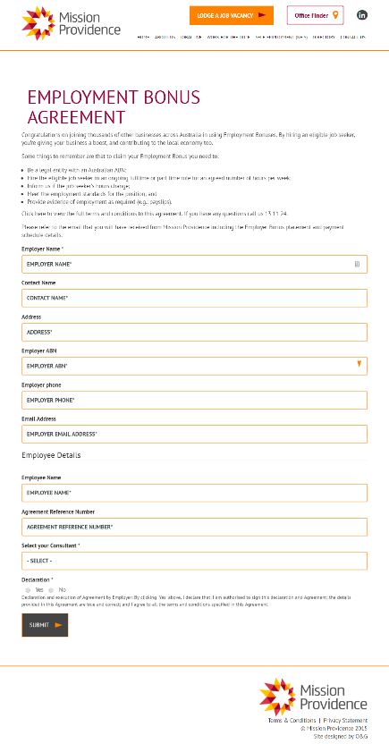

## 4.2 Promotional flyer

Our interviews with provider staff revealed a strong desire for written promotional materials to assist in discussing wage subsidies with employers. They felt these would be useful when the employer had no current vacancies or did not have time to talk, and was a good way of standardising positive messages to avoid reliance on the promotional skills of individual staff members. We co-designed an attractive  
one-page flyer with Mission Providence staff that aimed to provide employers with key information

regarding eligibility and the benefits for themselves and their employees. This behaviourally informed flyer uses clear messaging and a simple structure. Four versions with different images were created so provider staff could choose the one that matched the employer’s needs. **

Figure 17. One of the new wage subsidy promotional flyer

## 4.3 The new default payment structure

We found during our Explore phase that although the Department’s policy was that wage subsidy payments should be flexible, the administrative burden of calculating payments was discouraging this practice. Providers were instead advertising quarterly payments as the default to employers.

As previously discussed, the literature on loss aversion and hyperbolic discounting would indicate that earlier and back-loaded payments (where larger payments occur towards the end) should more effectively incentivise employment retention. Research from the Department also showed that employers wanted more money up-front. Our flexibility to implement this was limited, however, as the wage subsidies agreement was mandated to occur pro rata. Our solution was instead to increase the frequency of these payments across the first half of the year, with these payments back-loaded towards the middle of the year to encourage long term retention.

Presented below, this new payment structure has two important features:

* the first reward occurs very soon after the job seeker starts as a salient reinforcer of their employment; and
* the rewards are back-loaded within the first half of the year to encourage long-term employee retention.

Table 4. The revised wage subsidy payment structure

| **Week** | **3** | **6** | **14** | **28** | **40** | **52** | **Bonus – only for Restart (52)** |
| --- | --- | --- | --- | --- | --- | --- | --- |
| Amount | $375 | $375 | $1000 | $1750 | $1500 | $1500 | $2500 |

The primary reason the old quarterly default was preferred was because of the ease with which payments could be calculated (and aligned with employment outcome payments). We therefore complemented our new, more complex structure, with an easy to use spreadsheet calculator. This calculator allowed provider staff to quickly input the start date and other information for the job seeker to determine how much each payment instalment should be and the date it needed to be delivered. 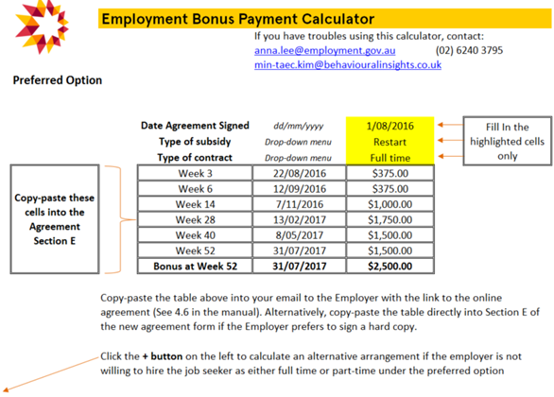

Figure 18. A screenshot of the new, easy to use wage subsidy calculator

Flexibility to input the desired payment schedule of an employer was still permitted within this new system, and in fact was made simpler through this payment calculator. This aimed to significantly decrease the administrative burden of calculating payment rates and dates for provider staff.

## 4.4 Scripts and email

Our Explore phase revealed a high degree of institutional knowledge about how to effectively promote subsidies, which had developed through staff experience. There were, however, substantial differences across sites and individual staff members, and no formal training for new staff as to the best method of promoting subsidies. Our telephone scripts and email templates therefore aimed to:

* standardise the best method of communication, using best practice insights from staff and behavioural science; and
* save provider staff time, especially with email where they could largely copy and paste responses.

This was a two stage co-design process. First, we had an initial workshop to gather insights from senior provider staff as to best practice communication methods. Then once we had designed and sent these scripts and templates to provider staff, we organised a second workshop to revise and refine them, with all workshop participants approving the final version.

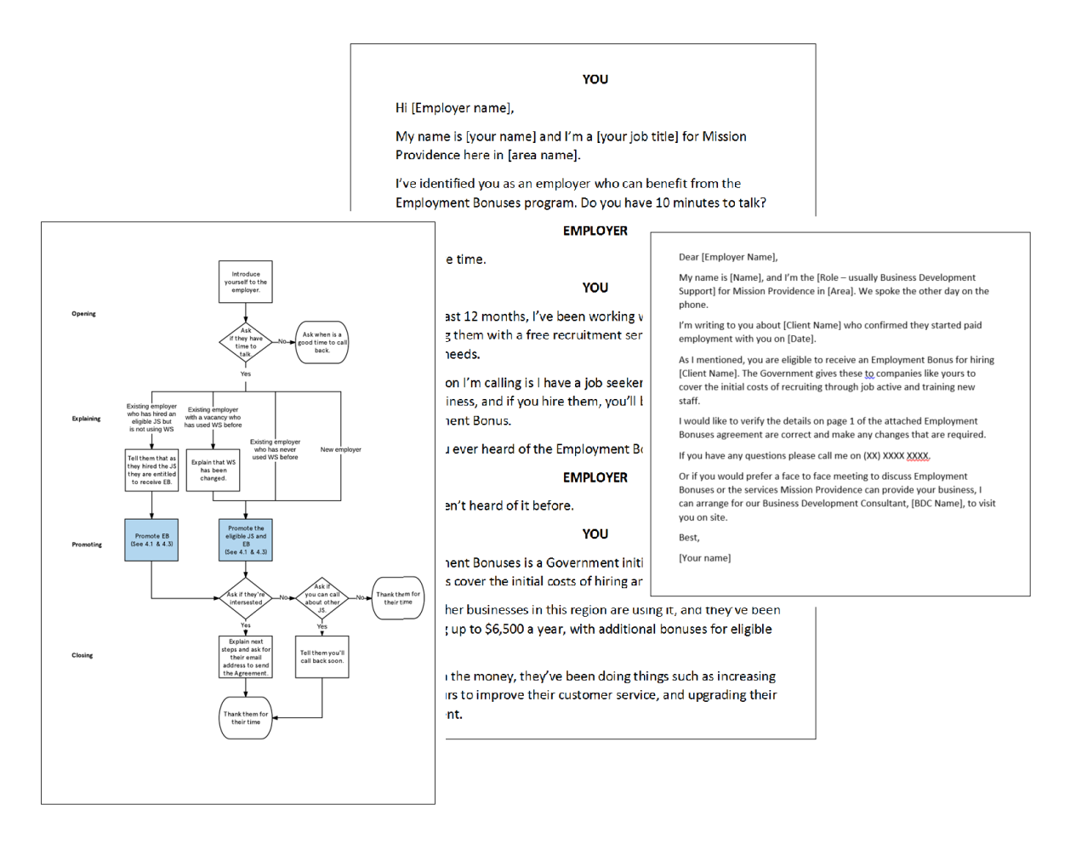

Figure 19. A selection of materials in the wage subsidies training manual

# 5. Trial

Following the Solutions phase, we took the interventions we developed and trialled them. The trial took place from 25 July 2016 to 1 November 2016, and covered seven separate offices that were managed by five business development teams (BDT)[4] of Mission Providence in South West Sydney. These teams had a combined case load of approximately 4,000 job seekers at any given time, of which approximately75 per cent[5] are eligible for a wage subsidy.

## 5.1 Design

The trial used a stepped-wedge trial design, randomised at the cluster level of the BDTs. This means that all teams started off in the control and then ‘crossed-over’ to being in the treatment in a randomised order.

When each team entered the treatment group, they were trained to:

* approach employers with the new script;
* offer employers a wage subsidy with a new payment structure; and
* broker wage subsidies using the redesigned process.

We chose to implement a stepped-wedge design due to three key considerations:

1. **Difficulty of randomising at the individual or team level:** Randomisation at these levels would require each team to keep track of which clients were in control and which were in treatment, and use a different process for each group. Thus, we were restricted to designs that randomised at the BDT level to avoid placing an unreasonable burden on each team. Further, in the event of an employer hiring two or more eligible job seekers, there was a risk that different job seekers would have been in both control and treatment, making it hard to prevent contamination of results.
2. **Differing outcomes by BDT:** We observed that outcomes differ significantly between BDTs. This meant that we wanted to choose a design that would allow us to control for the impact of the differing levels of experience, skills, employer pool, and other unobserved factors between BDTs. This was particularly important to consider for future replication and up-scaling across the country.
3. **Difficulty in switching out of treatment into control:** As our interventions focused on helping BDTs to do their jobs more effectively, we expected it to be difficult for teams to return to “business as usual” once they had been in the treatment group, as we would not be able to ensure that they did not use the resources they had been provided in the treatment.

A stepped-wedge design allowed us to randomise at the BDT level, and gave us the ability to control for the impact of each individual team. This design also allowed each BDC to remain in the treatment group until the end of the trial, so no team had to return to “business as usual” after entering the treatment group.

## 5.2 Evaluation questions

### Primary evaluation questions

The primary aim of our interventions was to increase the take-up of wage subsidies, and make it more effective at improving employment outcomes for job seekers.

The evaluation questions are summarised below:

Table 5. Our primary intervention evaluation questions

| **Research question** | **Unit of observation** | **Sample selection** | **Outcome variable** |
| --- | --- | --- | --- |
| Did the intervention increase the take-up of wage subsidies? | Job seeker[6] | All eligible job seekers | Job seeker placed with a wage subsidy agreement? (TRUE or FALSE) |
| Did the intervention increase the number of days the job seeker remained in employment? | Job seeker[7] | All eligible job seekers | Days in employment of those that are placed and have a wage subsidy (positive integer) |

### Secondary evaluation questions

We also assessed the impact of the intervention on two intermediate outcomes. Understanding the impact of the intervention on these outcomes helped us to understand aspects of the intervention that worked, and helped to explain results that we saw in the primary evaluation questions.

These secondary evaluation questions are summarised below:

Table 6. Our secondary intervention evaluation questions

| **Research question** | **Unit of observation** | **Sample selection** | **Outcome variable** |
| --- | --- | --- | --- |
| Did the intervention make employers sign agreements sooner? | Job seeker | All job seekers with a signed wage subsidy agreement | Number of days between receiving the agreement and the agreement being finalised (positive integer). |
| Did the intervention increase promotional activity across BDCs? | Activity | All promotional activities | Number of activities recorded per day when in control versus when joining treatment (positive integer). |

In addition to these outcomes, we tracked other intermediate outcomes and process measures, including a pre and post-trial survey with staff. A full list of outcomes and measures is provided in the Trial Protocol.

## 5.3 Randomisation

At the beginning of the trial, and every two weeks thereafter, a BDT was randomly allocated to the treatment group. These teams were given little warning (i.e. one or two days) that they had been randomly selected in order to limit their opportunities to change their behaviour in anticipation of joining the treatment group.

The randomisation was conducted by placing the names of each of the teams remaining in the control group into an opaque container and drawing them out. A video was recorded of this process, and sent to the BDT that was chosen to join the treatment group. This process resulted in the following allocation of teams to the treatment group.

Figure 20. Team allocation to the treatment group

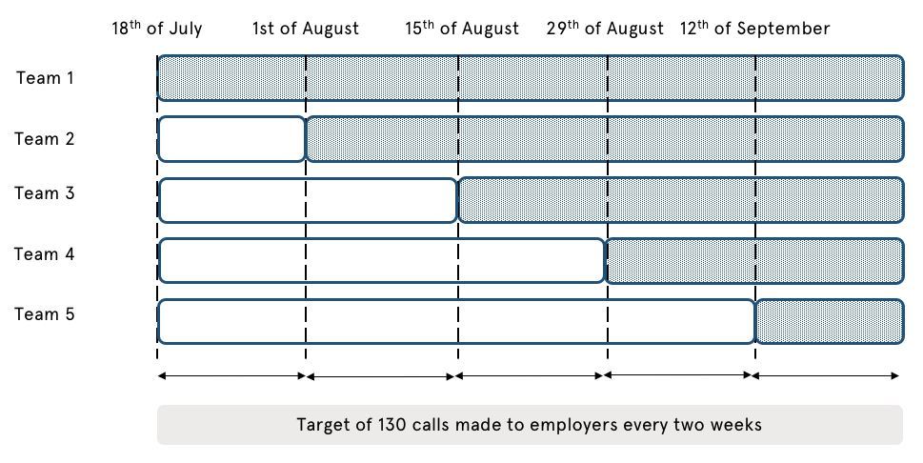

## 5.4 Analysis

We analysed the impact of the treatment using a model that accounted for the difference between BDTs and time periods, and estimated a single treatment effect which can be interpreted as the average causal impact of our interventions on the outcome.

We used identical specifications for all four outcome variables to ensure consistency in interpretation. Full regression tables are provided for each estimate in Appendix G.

## 5.5 Results

### Primary evaluation questions

**Did the intervention increase the take-up of wage subsidies?**

Based on our regression analysis, and controlling for all other factors, the intervention increased the number of agreements signed per day (Figure 21). Put another way, the intervention added an additional two agreements to the number signed per month at each site. If it was rolled out to all 64 sites of Mission Providence, more than 1,500 additional agreements would be signed per year. Whilst we found a strong directional effect, this result was not statistically significant at conventional levels (p=0.3). This could be attributable to our sample size being smaller than originally envisaged.

Based on our regression analysis, and controlling for all other factors, the intervention increased the number of agreements signed per day (Figure 21). Put another way, the intervention added an additional two agreements to the number signed per month at each site. If it was rolled out to all 64 sites of Mission Providence, more than 1,500 additional agreements would be signed per year. Whilst we found a strong directional effect, this result was not statistically significant at conventional levels (p=0.3). This could be attributable to our sample size being smaller than originally envisaged.

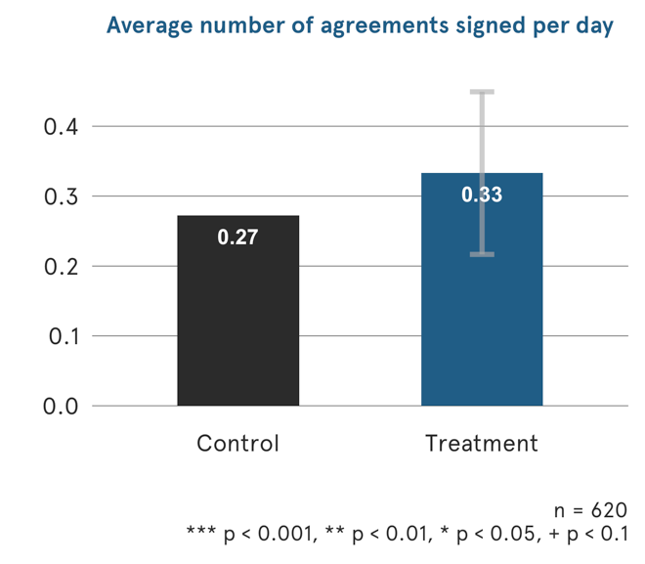

Figure 21. Trial result – average number of agreements signed per day

**Did the intervention increase the number of days the job seeker remained in employment?**

Looking at the proportion of individuals that reach four weeks of employment in each condition, we see a small decrease in the proportion that reach four weeks of employment in the treatment group.

Taken alone, this result might suggest that the intervention may have led to a negative effect. However, the reduction in the four week outcomes needs to be considered in conjunction with the higher level of new agreements being signed. Furthermore, the small sample size of job seekers who obtained a job with a wage subsidy agreement, which is an even smaller subset of the trial population, makes this metric highly vulnerable to small or

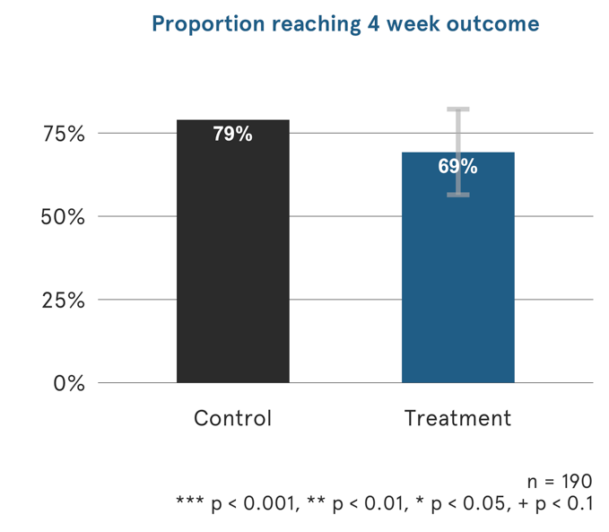

Figure 22. Trial result – proportion of job seekers reaching the 4 week outcome

random chance changes, and should be treated with a high degree of caution. This impact was also not statistically significant at conventional levels (p=0.14).

We also see small decreases in the proportion of individuals that reach 12 and 26 week employment outcomes in the treatment group. As before, these two results are not significant at conventional levels (p=0.40 and 0.95 respectively).

Secondary evaluation questions

**Did the intervention make employers sign agreements sooner?**We estimate that the intervention decreased the time taken to sign an agreement from an average of 17 days to 11 days, and this was marginally significant (p = 0.08). This means that during the trial period, the intervention saved BDTs over 500 days of waiting.

**Did the intervention make employers sign agreements sooner?**

We estimate that the intervention decreased the time taken to sign an agreement from an average of 17 days to 11 days, and this was marginally significant (p = 0.08). This means that during the trial period, the intervention saved BDTs over 500 days of waiting.

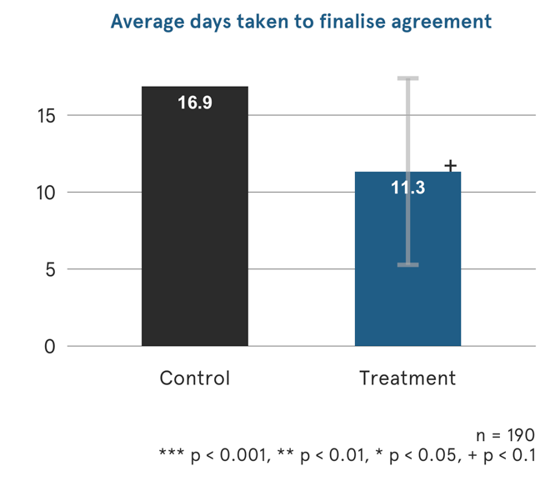

Figure 23. Trial result – average number of days taken to finalise agreement

**Did the intervention increase promotional activity across BDCs?**The intervention significantly increased promotional activities by 60 per cent, which is strong evidence to suggest that our interventions made it easier for the BDTs to promote wage subsidies and do more wage subsidy related activity. This would equate to 2,880 more promotional activities per month across all 64 Mission Providence sites.

**Did the intervention increase promotional activity across BDCs?**

The intervention significantly increased promotional activities by 60 per cent, which is strong evidence to suggest that our interventions made it easier for the BDTs to promote wage subsidies and do more wage subsidy related activity. This would equate to 2,880 more promotional activities per month across all 64 Mission Providence sites.

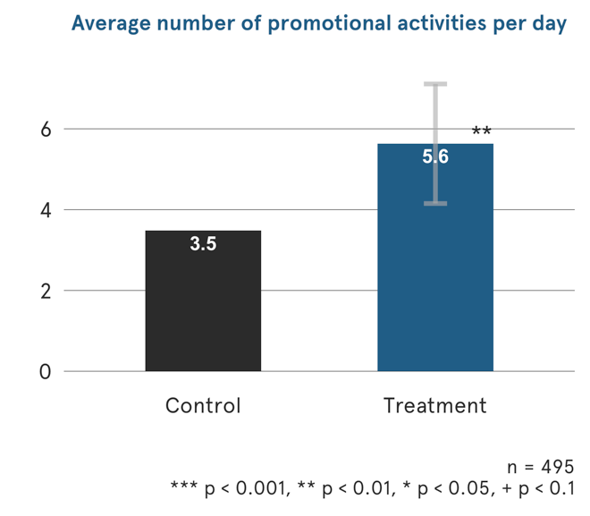

Figure 24. Trial result – average number of wage subsidy activities done by job advisors per day

**Did the intervention increase the hours of work for job seekers?**

We found that the intervention increased the number of hours worked by job seekers by an average of two hours per week per wage subsidy. This impact was marginally significant (p = 0.09).

**Did the intervention decrease the administrative burden on staff?**

The business development consultants (BDCs) that implemented the intervention reported that there was a reduction in the time taken to do common tasks. They reported that:

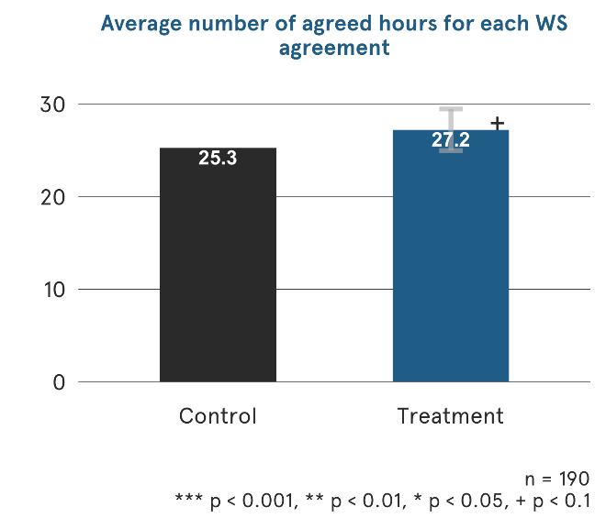

Figure 25. Trial result – average number of agreed hours per wage subsidy agreement

* Promotional activity was quicker – approximately four times faster with easy cases and twice as fast with difficult cases.
* Calculating subsidies was faster – approximately four times faster with easy cases and eight times faster with difficult cases.
* All components of the interventions were seen as useful by at least 50 per cent of the BDCs.

The results of the trial are summarised in Table 7.

Table 7. Summary of results

| **Result** | **Key findings** |
| --- | --- |
| More wage subsidies signed | An additional two agreements were signed per month at each site. This would equate to more than 1,500 additional agreements being signed per year if the trial was rolled out to all of Mission Providence’s 64 sites. |
| Wage subsidies signed at a faster rate | The time it took to sign an agreement reduced from an average of 17 to 11 days. |
| Promotional activities increased | Frontline staff at Mission Providence increased their promotional activities by 60 per cent. This would equate to 2,880 additional promotional activities per month if the trial was rolled out to all of Mission Providence’s 64 sites. |
| The number of hours worked increased | Job seekers with a wage subsidy worked an extra two hours per week. |
| Reduction in the time taken to do administrative tasks | BDCs noted that promotional activity and calculating wage subsidies were faster during the trial period. |

# 6. Conclusion

The Behavioural Insights Team and the Department, in partnership with Mission Providence, undertook a trial to increase the take-up of wage subsidies. An extensive research period helped identify the most cost-effective solutions to be tested and areas where insights from behavioural economics could provide value-add. These solutions included, among others:

* A change in the administrative processes, including transitioning from a long paper-based and complex wage subsidy agreement to an clearer, online agreement with an electronic signature and without a pro-rata table;
* a set of promotional and training materials, such as flyers and phone scripts, to help Mission Providence staff promote subsidies more effectively; and
* a different default setting for payment instalments.

The new approach was tested across five sites of Mission Providence in South West Sydney, on a sample of 1,436 employers, between 25 July 2016 to 1 November 2016. The effectiveness of the new approach was evaluated using a cluster Randomised Control Trial, with a stepped-wedge design.

We found that our intervention caused an increase in agreements signed but a reduction in the likelihood of being employed for at 4 weeks, 12 weeks and 26 weeks. However, these differences were not significant at conventional levels. The intervention also resulted in a reduction of the time taken to finalise an agreement, although this did not reach conventional levels of statistical significance. We also found a large and statistically significant increase in promotional activity.

These results suggest that the intervention was effective in increasing the number of wage subsidy agreements entered into, but due to a lower than expected sample size, our trial ultimately did not have the power to allow us to be more definitive about the efficacy of our interventions. In addition, the drive to increase agreements possibly lead to less efficiency given the limited evidence that they did not stick at 4, 12 and 26 weeks.

Feedback received during the trial fine-tuned the final design and implementation of operational policy changes to wage subsidies announced in the 2016 Budget and implemented nationally on 1 January 2017. These include:

* Giving employers longer to sign up to an agreement: wage subsidy agreements can be signed up to 12 weeks after the job starting, extended from four weeks.
* Making the application and payment processes easier: improving online functionality for employers and providers to simplify eligibility, agreements and claim processes.
* Providing more timely financial support: a discretionary kickstart payment option of up to 40 per cent can be made four weeks after the job seeker starts in the job.
* All wage subsidies paid to employers over six months instead of the previous 12 months.
* Increasing flexibility for employers and job seekers: moving to an average of 20 hours worked per week over the six month agreement rather than a minimum requirement of 15 hours per week worked.

# Appendices

## Appendix A – Summary of BIT TEST Framework

TEST includes four key components:

Table 8. The TEST framework

|  |  |  |  |
| --- | --- | --- | --- |
| Target | Image of a question mark | Define The Problem | Define the problem and, importantly, the measurable outcome we are aiming to achieve.  Think carefully about the specific behaviours we would like to encourage or discourage, and how the impact of these changed behaviours can be measured. |
| Explore | Image of a globe with a location marker on it | Understand The Context | Understand the perspective of the end user (the person whose actions / behaviour is the focus of the project).  Understand the system in which existing interventions are delivered. |
| Solution | Image of tools | Design The Intervention | Co-design with staff and end-users effective behavioural interventions. |
| Trial | Image of a stylised bar graph | Test, Learn, Adapt | Design a trial to determine the causal impact of the intervention to a high degree of scientific rigour.  Analyse the data, adapt the intervention, if necessary, to improve results, and provide recommendations. |

## Appendix B – Expression of Interest to recruit trial partner

Would you like to work with Behaviour Change experts to improve your Wage Subsidy outcomes?

1. The Department has recently established an Applied and Behavioural Economics Team. The Team is now working with experts in the field to apply behavioural economics principles to increase the uptake of wage subsidies by employers to help jobseekers in vulnerable groups gain employment.

**We are now seeking jobactive providers to partner with us to co-design and implement innovative behavioural economics solutions to this challenge.**

***We can only work with a limited number of providers, so please get in contact soon!***

**What do I need to do now?**

If you are interested in working with the Department on these projects, please complete the short form attached. This will help us to understand whether you are best suited to work with us on the project.

**What happens next?**

Once we have collected the information on the next page, we will be in contact to discuss the project in more detail. Even if you are not selected this time, we may work with you in the future on similar initiatives.

**What is the project?**

*Wage Subsidies:* The Department administers five different wage subsidy programmes to encourage employment. This project will aim to increase the uptake of the wage subsidy programmes by small to medium enterprises.

**What are the benefits of collaborating on this project?**

You will have the opportunity to improve the outcomes and uptake of wage subsidies.

You will also have the opportunity to work alongside behavioural economics experts, increasing the capability of your staff in this field through knowledge sharing and skills transfer.

**Application Form** *(as attachment to the email)*

If you would like to be actively involved in the design and implementation of this behavioural economics project, please provide us with the following information by no later than **18:00h DD/MM/YYY**.

Please provide below the contact details of yourself or someone else in your organisation that we can contact to discuss this opportunity further.

Name:  
Role in the organisation:  
Phone:  
Email:  
Address:

**Quick questions:**  
How many wage subsidies[8] have you disbursed over the past six months (cumulative from all your offices)?

| Month | Jul | Aug | Sept | Oct | Nov | Dec |
| --- | --- | --- | --- | --- | --- | --- |
| No. of wage subsidies disbursed |  |  |  |  |  |  |

How many offices do you have around Australia?

|  |  |
| --- | --- |
| No. of offices |  |

## Appendix C – Partner Selection Criteria

| **Selection Criteria** | **Rationale** |
| --- | --- |
| Number of sites in NSW and ACT | The provider had to have at least two offices in either NSW or ACT, the respective locations of BIT and the Department, to keep implementation costs within available resources. |
| Accuracy of data on wage subsidies | Reliable and detailed data was required by the provider to complement the existing dataset of the Department in order for the trial to be based on a robust evaluation methodology. |
| Capabilities and capacity | The provider was expected to nominate a number of offices in NSW or ACT whose Managers (or Regional Manager) were willing and had capacity to support and oversee the implementation of the trial on the ground. |
| Sample size | In order to detect statistically significant effects between the current and revised models, providers with a larger sample size of eligible job seekers were prioritised. |

## Appendix D – Deed of Understanding

A copy of the Deed of Understanding between BIT, the Department and Mission Providence can be provided by the Applied and Behavioural Economics Section of the Department separately upon request.

## Appendix E – Explore material

### Wage Subsidy Roadshow Group Interview – Participant Information Statement

Wage Subsidies Research Project

Group Interview

Thank you for taking the time to participate in this group interview. This session will be building upon the broad discussion on wage subsidies that took place earlier.

***Objectives***

* This group interview is conducted for the purposes of research to assist us in gaining a better understanding of how wage subsidies work on the ground.
* This research project is conducted by the Applied and Behavioural Economics Section at the Department of Jobs and Small Business in collaboration with the Behavioural Insights Team.
* The questions that will be asked are strictly to gather insights into how the  
  Department of Jobs and Small Business can better support providers in administering wage subsidies, and will not be used as a means of monitoring or performance assessments.
* We expect the group interview to take approximately 30 minutes.

***Confidentiality***

* Any information collected will remain confidential and anonymous.
* If preferred, you do not need to state your surname or organisation at any point of this group interview.

***Contact us***

If you would like to further discuss other aspects of your work with us after this interview, please leave your contact details with the interviewer. We will contact you over the next few weeks.

### Group Interview Questions

Introduction

[The interviewer introduces herself/himself]

Thank you for taking the time to participate in this group interview. This session will be building upon the broad discussion on wage subsidies that took place earlier.

This group interview is conducted for the purposes of research to assist us in gaining a better understanding of how wage subsidies work on the ground. This research project is conducted by the Applied and Behavioural Economics Section at the Department of Jobs and Small Business in collaboration with the Behavioural Insights Team.

Any information collected during this interview will remain confidential and anonymous. If preferred, you do not need to state your surname or organisation.

Ice-breaker (optional)

Can you tell us a bit about yourself and your role in the organisation you work with?

Interview questions guidelines

1) We have just heard in the earlier session that …. [summarise two/three key observations from the main session], do you agree?

2) How do you promote wage subsidies to employers?

3) Can you describe the process of negotiating how payments are allocated over the course of the wage subsidy agreement with an employer?

a) What strategies do you have for continuing to engage with employers after the wage subsidy agreement has been formalised? E.g. after six months.

4) How do employers usually react when you tell them that a job seeker they might hire is eligible for a wage subsidy?

a) What strategies do your staff utilise to counter any negative responses?

5) Do your staff tell job seekers they are eligible for a wage subsidy? How do they usually react?

a) What strategies do your staff utilise to counter any negative responses?

Additional wrap-up questions

6) Do you think wage subsidies can improve employment opportunities of some job seekers?

If you would like to discuss further other aspects of your work with us after this interview, please leave your contact details to the interviewer. We will contact you over the next few weeks.

### Wage subsidy roadshow – survey (for information purposes only)

**Survey on wage subsidies (not for completion)**

This survey is conducted for the purposes of research to assist us in gaining a better understanding of how wage subsidies work on the ground. Any information collected will remain confidential and anonymous.

**Question 1**

How much do you agree or disagree with the following statement:

*“Most employers would find a wage subsidy attractive”*

* Strongly agree
* Agree
* Neither agree nor disagree
* Disagree
* Strongly disagree

**Question 2**

What type of employers do you think are more likely to be attracted by wage subsidies? (Select all that apply)

* Sole traders
* Small-medium enterprises
* Large companies
* Multinational and very large companies

**Question 3**

What sector do you think is more attracted by wage subsidies? (Select all that apply)

* Manufacturing
* Accommodation and Food Services
* Retail Trade
* Construction
* Transport, Postal and Warehousing
* Agriculture, Forestry, Fishing
* Professional, Scientific, Technical
* Wholesale Trade
* Health Care and Social Assistance
* Other (please specify): ………..

**Question 4**

How frequently do you think job advisors would normally discuss about wage subsidies with employers?

* Always, with every eligible job seeker
* Sometimes, with some eligible job seekers
* Sporadically, with very few job seekers
* Never

**Question 5**

How much do you agree or disagree with the following statement:

*“Wage subsidies are easy for job advisers to manage and administer”*

* Strongly Agree
* Agree
* Neither agree nor disagree
* Disagree
* Strongly Disagree

**Question 6**

How much do you agree or disagree with the following statement:

*“Wage subsidies represent a good opportunity to improve employment outcomes for eligible job seekers”*

* Strongly Agree
* Agree
* Neither agree nor disagree
* Disagree
* Strongly Disagree

**Question 7**

For what type of job seeker do you think a wage subsidy would increase her/his chance of employment? (Select all that apply)

* Long-term unemployed job seekers
* Older unemployed job seekers
* Younger unemployed job seekers
* Less disadvantaged and short-term unemployed
* Others (please specify): ………..

**Question 8**

How much do you agree or disagree with the following statement:

*“I prefer not to mention wage subsidies to an employer as I am afraid it would send the wrong message about the quality of a job seeker I am trying to help”*

* Strongly Agree
* Agree
* Neither agree nor disagree
* Disagree
* Strongly Disagree

**Question 9**

What is your role in your organisation?

* CEO/Managing Director
* Regional Manager/Senior Manager
* Senior Officer
* Officer
* Trainee/apprentice

**Question 10**

How many people work in your office?

* Less than 5
* Between 6 and 10
* Between 11 and 20
* Between 20 and 40
* More than 40

**Question 11**

How many offices does your organisation have in Australia?

* Less than 5
* Between 6 and 10
* Between 11 and 20
* Between 20 and 40
* More than 40

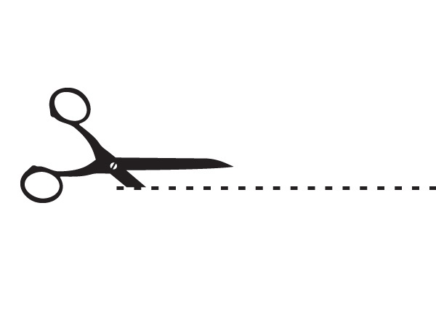

**Contact details (optional)**

We would like to have the opportunity to discuss further with you some aspects of the wage subsidies project as well as other research projects we are currently conducting. If you would like to be contacted, please insert below your preferred method of communication and we will be in touch over the next few weeks.

|  |  |
| --- | --- |
| Name: | Organisation: |
| Phone: | **Email:** |

**Please note:** the answers you provided in this survey will still be kept anonymous. If you prefer, you can cut this part of the paper and place it in the same box.

## Appendix F – Trial Protocol

A copy of the Trial Protocol can be provided by the Applied and Behavioural Economics Section of the Department separately upon request.

## Appendix G – Regression tables

### Wage subsidy agreements signed

|  |  |  |
| --- | --- | --- |
|  | *Model: Linear Mixed effects Model* | |
|  |  | |
|  | *Dependent variable:*  *Number of agreements signed per day* | |
| Treatment group | 0.061 | |
|  | (0.059) | |
|  |  | |
| Constant | 0.272*** | |
|  | (0.085) | |
|  |  | |
| Random effects for location? | Yes | |
|  |  | |
|  |  | |
| Random effects for week? | Yes | |
|  | |  |
| Observations | 620 | |
| AIC | 1,324 | |
|  | | |
| *Note: Standard errors in parentheses* | *p<0.05; **p<0.01; ***p<0.001 | |

### 4 week outcome

|  |  |  |
| --- | --- | --- |
|  | *Model: Linear Mixed effects Model* | |
|  |  | |
|  | *Dependent variable:*  *Individual employed at 4 weeks*  *(1 = TRUE, 0 = FALSE)* | |
| Treatment group | -0.096 | |
|  | (0.066) | |
|  |  | |
| Constant | 0.789*** | |
|  | (0.051) | |
|  |  | |
| Random effects for location? | Yes | |
|  |  | |
|  |  | |
| Random effects for week? | Yes | |
|  | |  |
| Observations | 190 | |
| AIC | 246 | |
|  | | |
| *Note: Standard errors in parentheses* | *p<0.05; **p<0.01; ***p<0.001 | |

### Time to finalisation

|  |  |  |
| --- | --- | --- |
|  | *Model: Linear Mixed effects Model* | |
|  |  | |
|  | *Dependent variable:*  *Number of days to finalisation* | |
| Treatment group | -5.526* | |
|  | (3.090) | |
|  |  | |
| Constant | 16.859*** | |
|  | (2.409) | |
|  |  | |
| Random effects for location? | Yes | |
|  |  | |
|  |  | |
| Random effects for week? | Yes | |
|  | |  |
| Observations | 163 | |
| AIC | 1428 | |
|  | | |
| *Note: Standard errors in parentheses* | *p<0.05; **p<0.01; ***p<0.001 | |

### Promotional activity

|  |  |  |
| --- | --- | --- |
|  | *Model: Linear Mixed effects Model* | |
|  |  | |
|  | *Dependent variable:*  *Number of promotional activities per day* | |
| Treatment group | 2.152*** | |
|  | (0.755) | |
|  |  | |
| Constant | 3.479*** | |
|  | (0.787) | |
|  |  | |
| Random effects for location? | Yes | |
|  |  | |
|  |  | |
| Random effects for week? | Yes | |
|  | |  |
| Observations | 495 | |
| AIC | 3309 | |
|  | | |
| *Note: Standard errors in parentheses* | *p<0.05; **p<0.01; ***p<0.001 | |

## Appendix H – References

Choi, J. J., Chan, K., Hirshleifer, D., Johnson, E., Merkle, C., & Previtero, A. (2012). Small Cues Change Savings Choices. NBER Working Paper No. 17843.

Frey, B. S., & Oberholzer-Gee, F. (1997). The cost of price incentives: An empirical analysis of motivation crowding-out. *The American economic review*, *87*(4), 746-755.

Fryer Jr, R. G., Levitt, S. D., List, J., & Sadoff, S. (2012). *Enhancing the efficacy of teacher incentives through loss aversion: A field experiment* (No. w18237). National Bureau of Economic Research.

Hossain, T., & List, J. A. (2012). The behavioralist visits the factory: Increasing productivity using simple framing manipulations. *Management Science*, *58*(12), 2151-2167.

Kamenica, E. (2012). Behavioral economics and psychology of incentives. *Annu. Rev. Econ.*, *4*(1), 427-452.

Laibson, D. (1997). Golden eggs and hyperbolic discounting. *The Quarterly Journal of Economics*, *112*(2), 443-478.

Madrian, B. C. (2012). Matching Contributions and Savings Outcomes: A Behavioral Economics Perspective. NBER Working Paper No. 18220. Retrieved from http://www.ifs.org.uk/wps/wp0433.pdf

Navarro-martinez, D. J., Salisbury, L. C., Lemon, K. N., Matthews, W. J., & Harris, A. J. L. (2011). Minimum required payment and supplemental information disclosure effects on consumer debt repayment decisions. Journal of Marketing Research, XLVIII, 60–77. https://doi.org/10.1509/jmkr.48.SPL.S60

Thaler, R. H., & Benartzi, S. (2004). Save more tomorrow™: Using behavioral economics to increase employee saving. *Journal of political Economy*, *112*(S1), S164-S187.

1. The locations were: Melbourne, Orange, Hobart, Newcastle, Brisbane, Sydney, Adelaide, Perth and Darwin.
2. Thaler & Benartzi (2004) were not able to randomise eligibility for the program. Hence, this estimate is based on the assumption that SMarT participants’ savings rate would have been unchanged in the absence of the program.

   This is a reasonable assumption because the savings rate of all other employees, including those that were not eligible for SMarT, did not change over this period. Nonetheless, some residual possibility of selection bias remains.
3. Most individuals seek to perceive themselves as consistent, and will alter their behavior to achieve this consistency. This can be used as a tool of social influence by asking people to make commitments to a behavior before this behavior needs to be performed (Guagagno, R. E. & Cialdini, R. B 2010).
4. One BDT was formed of one Business Development Consultant (BDC) and one Business Development Support Officer (BDS).
5. This is based on historical data provided to us by Mission Providence in early 2016.
6. Allocation to condition contingent on the status of the BDT when agreement is signed.
7. Allocation to condition contingent on the status of the BDT when agreement is signed.
8. The list of wage subsidies is available here: <https://www.employment.gov.au/wage-subsidies>.